Default Settings – Customer Parameters

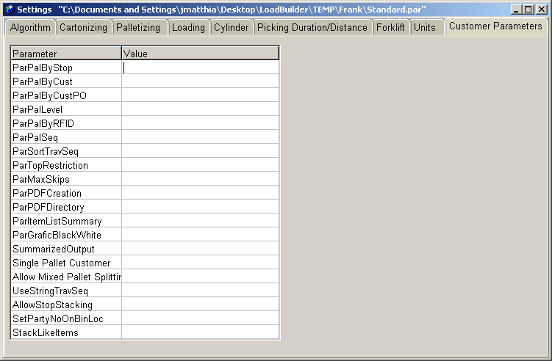

Specific Parameters that drive RedPrairie requested functionality:

Relevant Fields:
ParPalByStop: Palletize by relation (stop)

ParPalByCust: Palletize by customer (customer)

ParPalByCustPO: Palletize by Customer PO

ParPalLevel: Can be 0-3, 1-Building, 2-Work Zone, 3-Work Area

ParPalRFID: Palletize by RFID so RFID items are unique.

ParPalSeq: Build a pallet in the order of travel sequence. Should only be used in a case pick environment

ParSortTravSeq: Return data in travel sequence order within pallets.

PartTopRestriction: Can stack partial pallets on top of each other.

ParMaxSkips: How many picks can I skip while building pallets. Can I skip a travel sequence ordered case pick.

ParPDFCreation: Create a PDF report of the trailer and line items

ParPDFDirectory: Directory to save the PDF to if created

ParItemListSummary: Include an item list summary on the PDF

ParGraficBlackWhite: Use only black and white while generating the PDF

SummarizedOutput: Combine like cmbcod lines.

Single Pallet Customer: Single pallet per stack.

Allow Mixed Pallet Splitting: Not Used, we will never send mixed pallets to Load Designer.

UseStringTravelSequnce: RedPrairie allows a travel sequence to be up to 20 characters, enabling this allows Load Designer to support 20 character string travel sequences.

AllowStackStoping: Do not plan different stops into the same stop.

SetPartyNoOnBinLocation: Find the same picks from the same location and group them together. Keeps a picker from revisiting the same location twice on a list pick.

StackLikeItems: Keeps full pallet picks of like items together.

